Q1) Write a program to place Name, Age and mobile number linearly (Vertical) on the display screen using Linear Layout.
Code-
main_activity.xml

<?xml version="1.0" encoding="utf-8"?>
<LinearLayout xmlns:android="http://schemas.android.com/apk/res/android"
xmlns:app="http://schemas.android.com/apk/res-auto"
xmlns:tools="http://schemas.android.com/tools"
android:layout_width="match_parent"
android:layout_height="match_parent"
android:paddingLeft="16dp"
android:paddingRight="16dp"
android:paddingTop="16dp"
android:orientation="vertical"
tools:context=".MainActivity">

<TextView
android:layout_width="wrap_content"
android:layout_height="wrap_content"
android:text="Name: Sushant Dipak Shinde"/>

<TextView
android:layout_width="wrap_content"
android:layout_height="wrap_content"
android:text="Age: 19"/>

<TextView
android:layout_width="wrap_content"
android:layout_height="wrap_content"
android:text="Mobile Number: 00000 00000"/>
</LinearLayout>

Output-
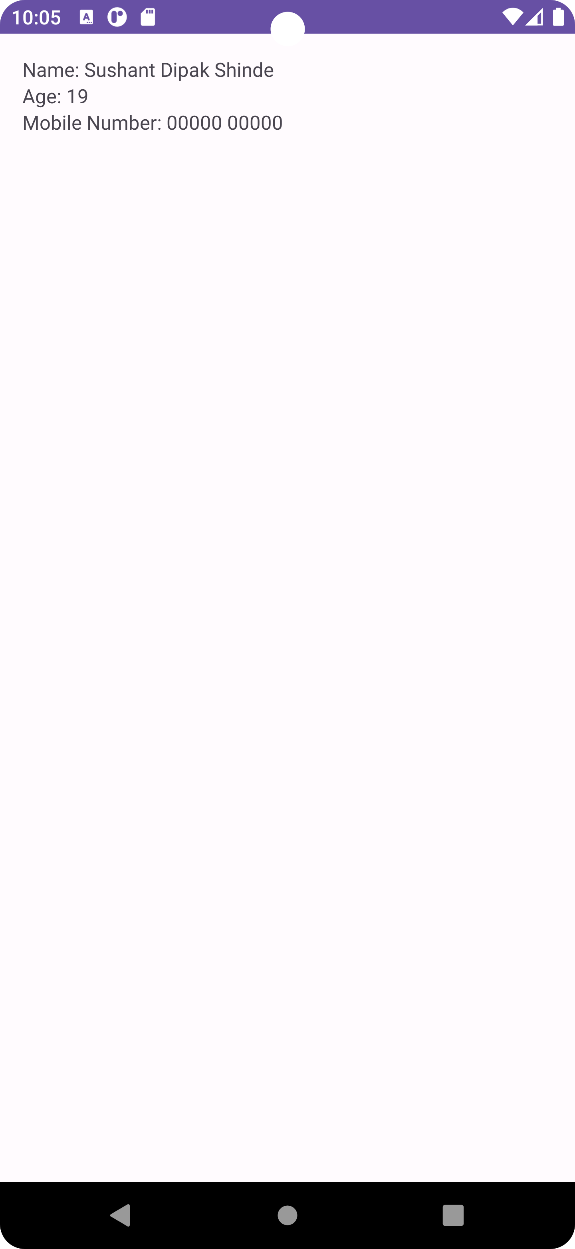

Q1) Write a program to accept Username & Password from the end user using TextView and EditText.
main_activity.xml
<? xml version="1.0" encoding="utf-8"?>
<TableLayout xmlns:android="http://schemas.android.com/apk/res/android"
xmlns:app="http://schemas.android.com/apk/res-auto"
xmlns:tools="http://schemas.android.com/tools"
android:layout_width="match_parent"
android:layout_height="match_parent"
android:padding="50dp"
tools:context=".MainActivity">

<TextView
android:layout_width="wrap_content"
android:layout_height="wrap_content"
android:gravity="center"
android:textSize="25dp"
android:text="Login Page" />

<TableRow
android:layout_width="match_parent"
android:layout_height="wrap_content"
android:gravity="center_horizontal">

<TextView
android:layout_height="wrap_content"
android:layout_weight="1"
android:gravity="center"
android:text="Enter UserName:" />

<EditText
android:id="@+id/user"
android:layout_width="169dp"
android:layout_height="60dp"
android:layout_weight="1"
android:hint="abc@gmail.com" />
</TableRow>

<TableRow
android:layout_width="match_parent"
android:layout_height="wrap_content"
android:gravity="center_horizontal">
<TextView
android:layout_height="wrap_content"
android:layout_weight="1"
android:gravity="center"
android:text="Enter Password:" />
<EditText
android:id="@+id/pass"
android:layout_width="169dp"
android:layout_height="60dp"
android:layout_weight="1"
android:hint="1234" />
</TableRow>
<Button
android:id="@+id/btn1"
android:layout_width="wrap_content"
android:layout_height="wrap_content"
android:layout_marginBottom="172dp"
android:text="Login" />
</TableLayout>
Output-
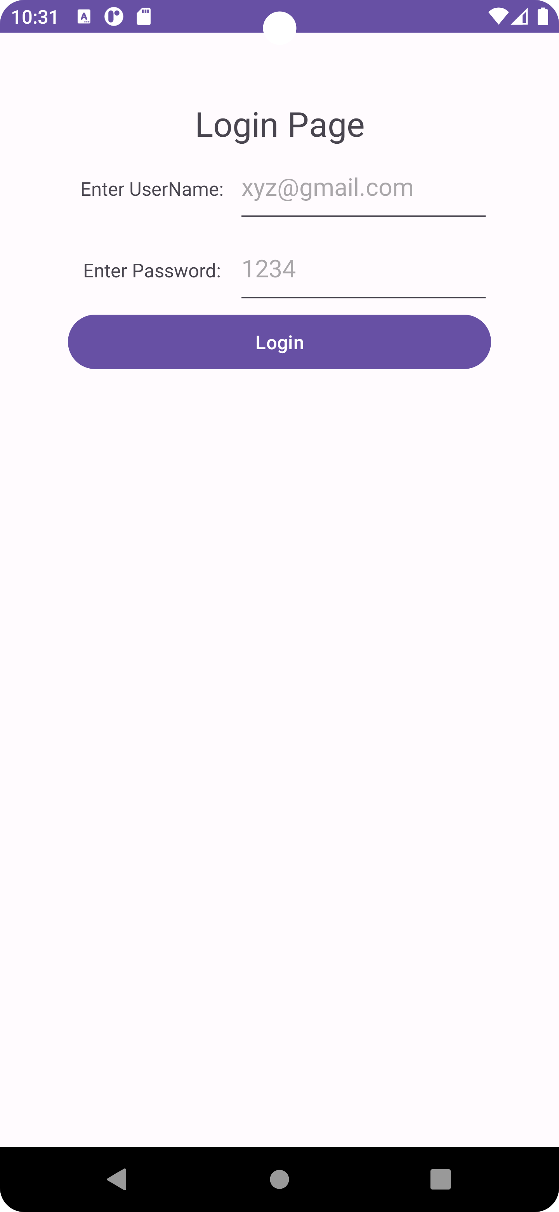

Q.1) Write a program to create a HelloWorld Activity using all lifecycles methods to display messages using Log.d.
main_activity.xml
<?xml version="1.0" encoding="utf-8"?>
<RelativeLayout xmlns:android="http://schemas.android.com/apk/res/android"
xmlns:app="http://schemas.android.com/apk/res-auto"
xmlns:tools="http://schemas.android.com/tools"
android:layout_width="match_parent"
android:layout_height="match_parent"
tools:context=".MainActivity">
<TextView
android:layout_width="wrap_content"
android:layout_height="wrap_content"
android:text="Hello World!"
android:textSize="25dp"
android:layout_marginTop="250dp"
android:layout_marginLeft="140dp"
app:layout_constraintBottom_toBottomOf="parent"
app:layout_constraintLeft_toLeftOf="parent"
app:layout_constraintRight_toRightOf="parent"
app:layout_constraintTop_toTopOf="parent" />
</RelativeLayout>

MainActivity.java

package com.example.practicalno17th;
import android.os.Bundle;
import android.util.Log;
import android.widget.Toast;
import androidx.appcompat.app.AppCompatActivity;
public class MainActivity extends AppCompatActivity {
@Override
protected void onCreate(Bundle savedInstanceState) {
super.onCreate(savedInstanceState);
setContentView(R.layout.activity_main);
Log.d("Activity_Lifecycle","onCreate invoked");
Toast.makeText(MainActivity.this,"Created",Toast.LENGTH_SHORT).show();
}
@Override
protected void onStart() {
super.onStart();
Log.d("Activity_Lifecycle","onStart invoked");
Toast.makeText(MainActivity.this,"Start",Toast.LENGTH_SHORT).show();
}
@Override
protected void onResume() {
super.onResume();
Log.d("Activity_Lifecycle","onResume invoked");
Toast.makeText(MainActivity.this,"Resume",Toast.LENGTH_SHORT).show();
}
@Override
protected void onPause() {
super.onPause();
Log.d("Activity_Lifecycle","onPause invoked");
Toast.makeText(MainActivity.this,"Pause",Toast.LENGTH_SHORT).show();
}
@Override
protected void onStop() {
super.onStop();
Log.d("Activity_Lifecycle","onStop invoked");
Toast.makeText(MainActivity.this,"Stop",Toast.LENGTH_SHORT).show();
}
@Override
protected void onRestart() {
super.onRestart();
Log.d("Activity_Lifecycle","onRestart invoked");
Toast.makeText(MainActivity.this,"Restart",Toast.LENGTH_SHORT).show();
}
@Override
protected void onDestroy() {
super.onDestroy();
Log.d("Activity_Lifecycle","onDestroy invoked");
Toast.makeText(MainActivity.this,"Destroy",Toast.LENGTH_SHORT).show();
}
}

Output-
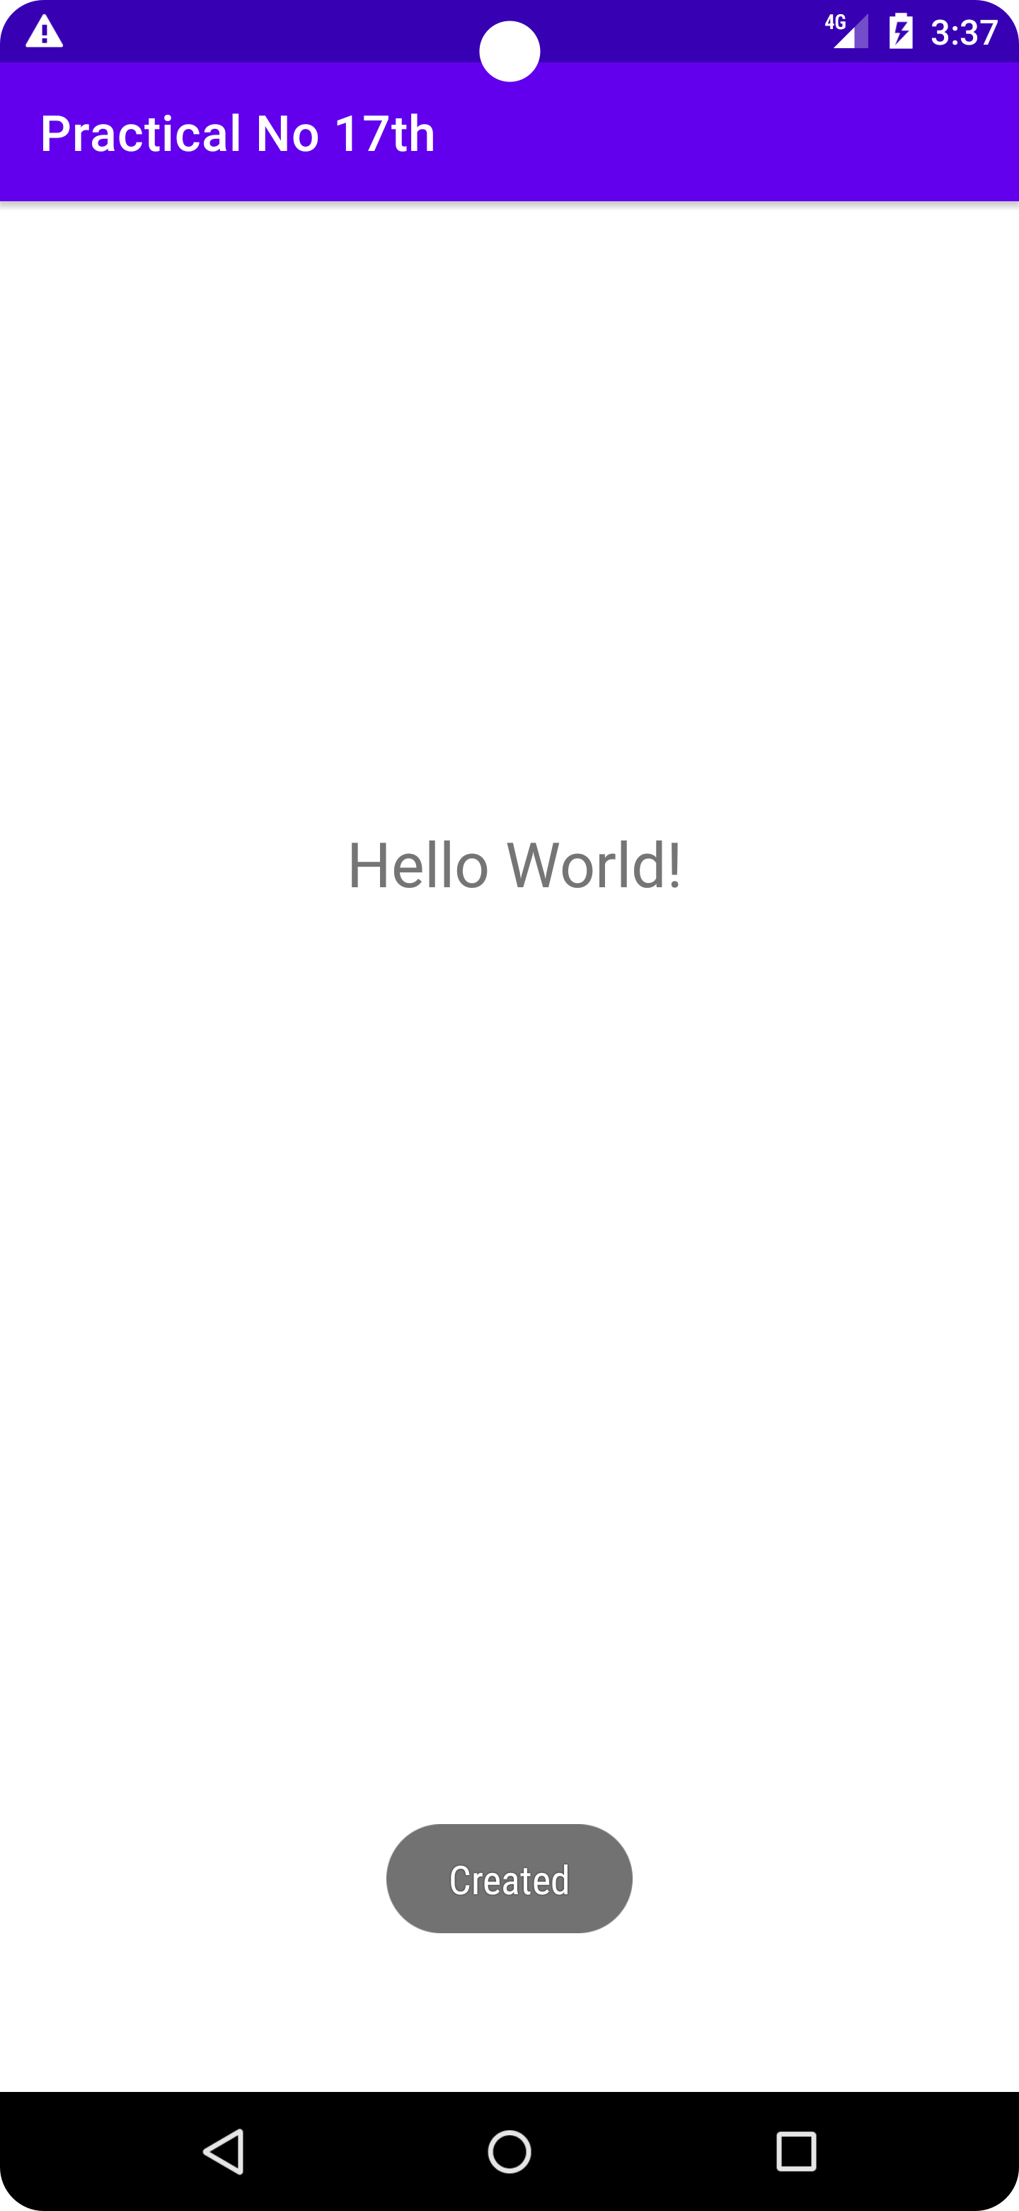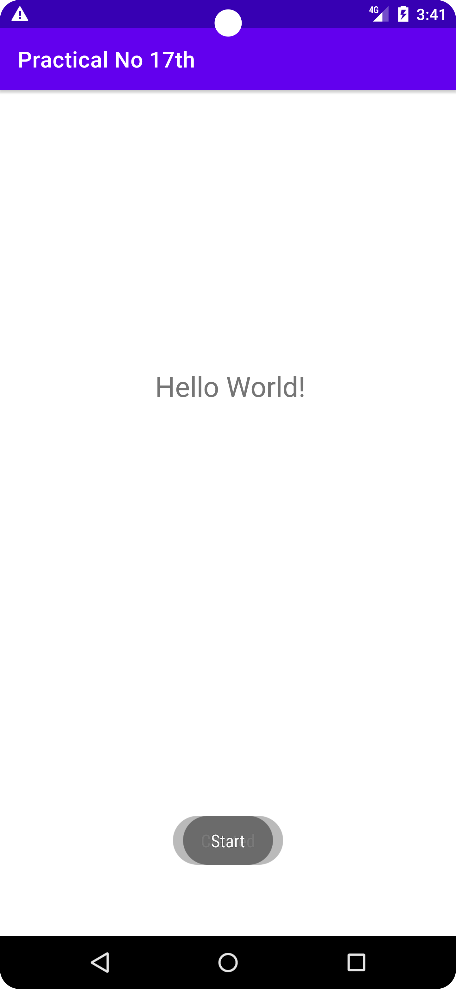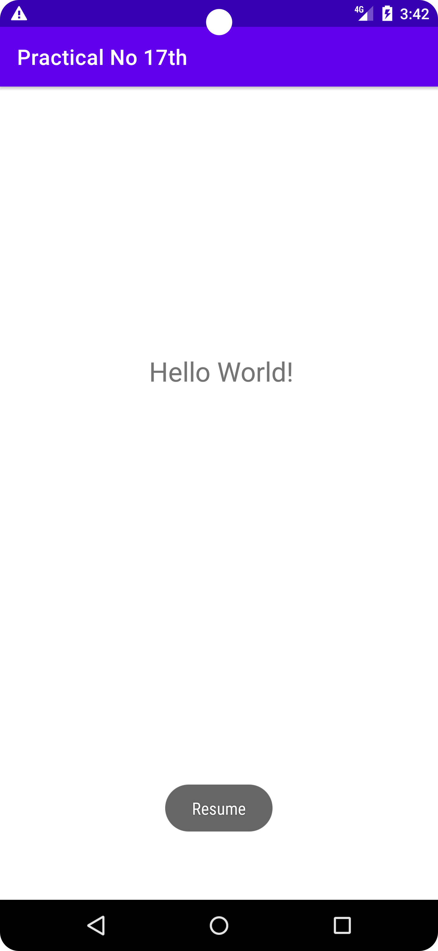

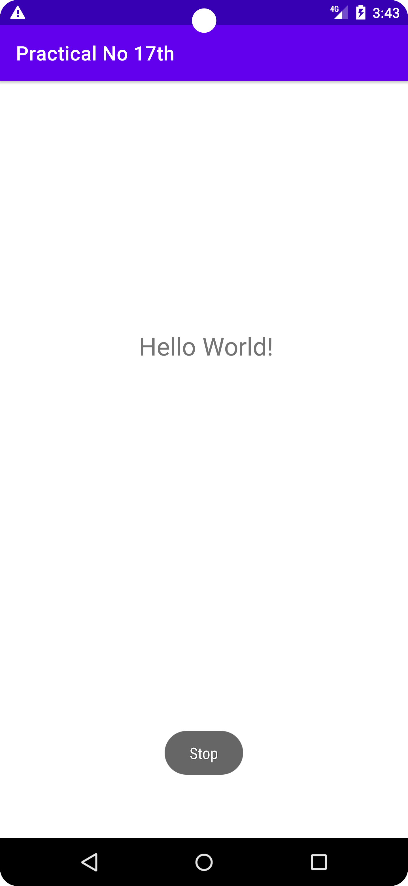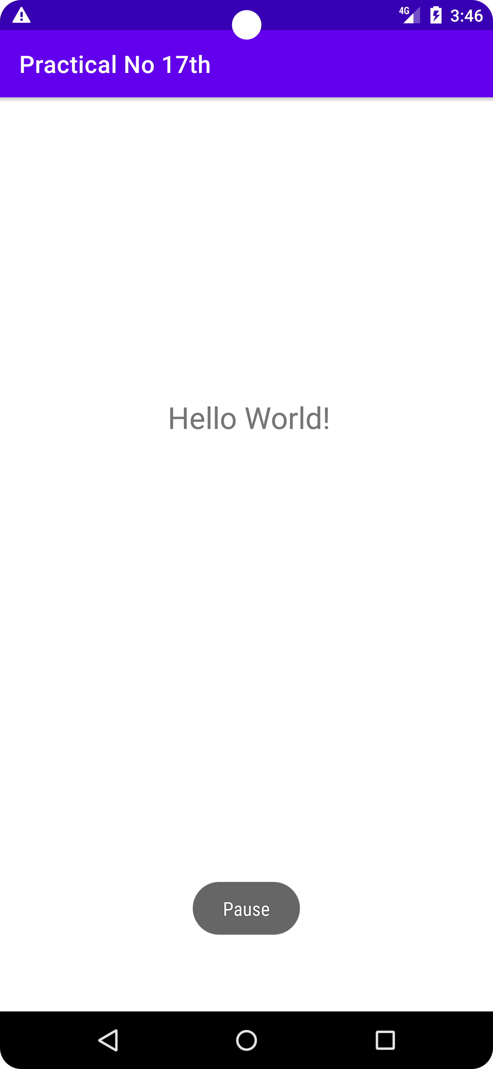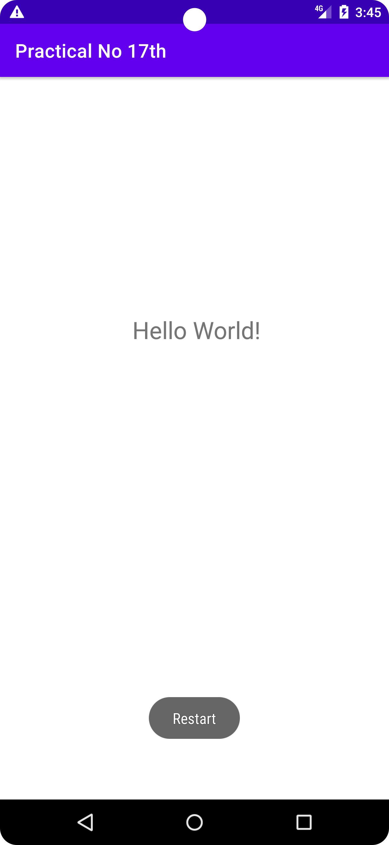

Q.3) Write a program to create two screens. First screen will take one number input from user. After click on Factorial button, second screen will open and it should display factorial of same number. Also specify which type of intent you will use in this case.
Activity main.xml
<?xml version="1.0" encoding="utf-8"?>
<LinearLayout xmlns:android="http://schemas.android.com/apk/res/android"
android:layout_width="match_parent"
android:layout_height="match_parent"
android:gravity="center"
android:orientation="vertical">

<EditText
android:id="@+id/input_field"
android:layout_width="wrap_content"
android:layout_height="wrap_content"
android:hint="Enter a number"
android:minHeight="48dp" />

<Button
android:id="@+id/factorial_button"
android:layout_width="wrap_content"
android:layout_height="wrap_content"
android:text="Factorial" />
</LinearLayout>
Activity main.java
package com.example.myapplication;
import android.content.Intent;
import android.os.Bundle;
import android.view.View;
import android.widget.Button;
import android.widget.EditText;
import androidx.appcompat.app.AppCompatActivity;
public class MainActivity extends AppCompatActivity {
@Override
protected void onCreate(Bundle savedInstanceState) {
super.onCreate(savedInstanceState);
setContentView(R.layout.activity_main);
// Find the input field and factorial button
EditText inputField = findViewById(R.id.input_field);
Button factorialButton = findViewById(R.id.factorial_button);
// Set an onClickListener for the factorial button
factorialButton.setOnClickListener(new View.OnClickListener() {
@Override
public void onClick(View view) {
// Get the input value
int inputValue = Integer.parseInt(inputField.getText().toString());

// Calculate the factorial
long factorial = calculateFactorial(inputValue);
// Open the second screen and pass the factorial as an extra
Intent intent = new Intent(MainActivity.this, SecondActivity.class);
intent.putExtra("factorial", factorial);
startActivity(intent);
}
});
}

private long calculateFactorial(int n) {
long result = 1;

for (int i = 1; i <= n; i++) {
result *= i;
}

return result;
}
}

Activity second.xml
<?xml version="1.0" encoding="utf-8"?>
<LinearLayout xmlns:android="http://schemas.android.com/apk/res/android"
android:layout_width="match_parent"
android:layout_height="match_parent"
android:gravity="center"
android:orientation="vertical">
<TextView
android:id="@+id/factorial_text_view"
android:layout_width="wrap_content"
android:layout_height="wrap_content"
android:textSize="24sp" />
</LinearLayout>
Activity Second.java
package com.example.myapplication;// SecondActivity.java
import android.content.Intent;
import android.os.Bundle;
import android.widget.TextView;
import androidx.appcompat.app.AppCompatActivity;
public class SecondActivity extends AppCompatActivity {
@Override
protected void onCreate(Bundle savedInstanceState) {
super.onCreate(savedInstanceState);
setContentView(R.layout.activity_second);
// Find the factorial text view
TextView factorialTextView = findViewById(R.id.factorial_text_view);
// Get the factorial extra from the intent
long factorial = getIntent().getLongExtra("factorial", 0);
// Set the factorial text
factorialTextView.setText("Factorial: " + factorial);
}
}
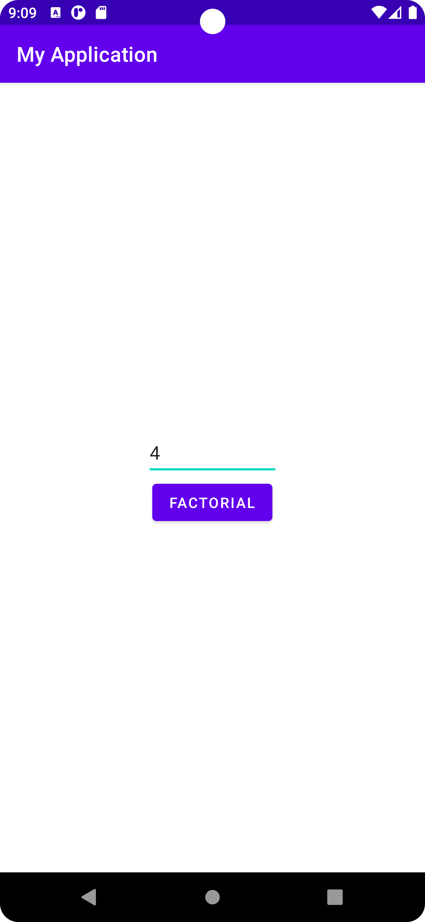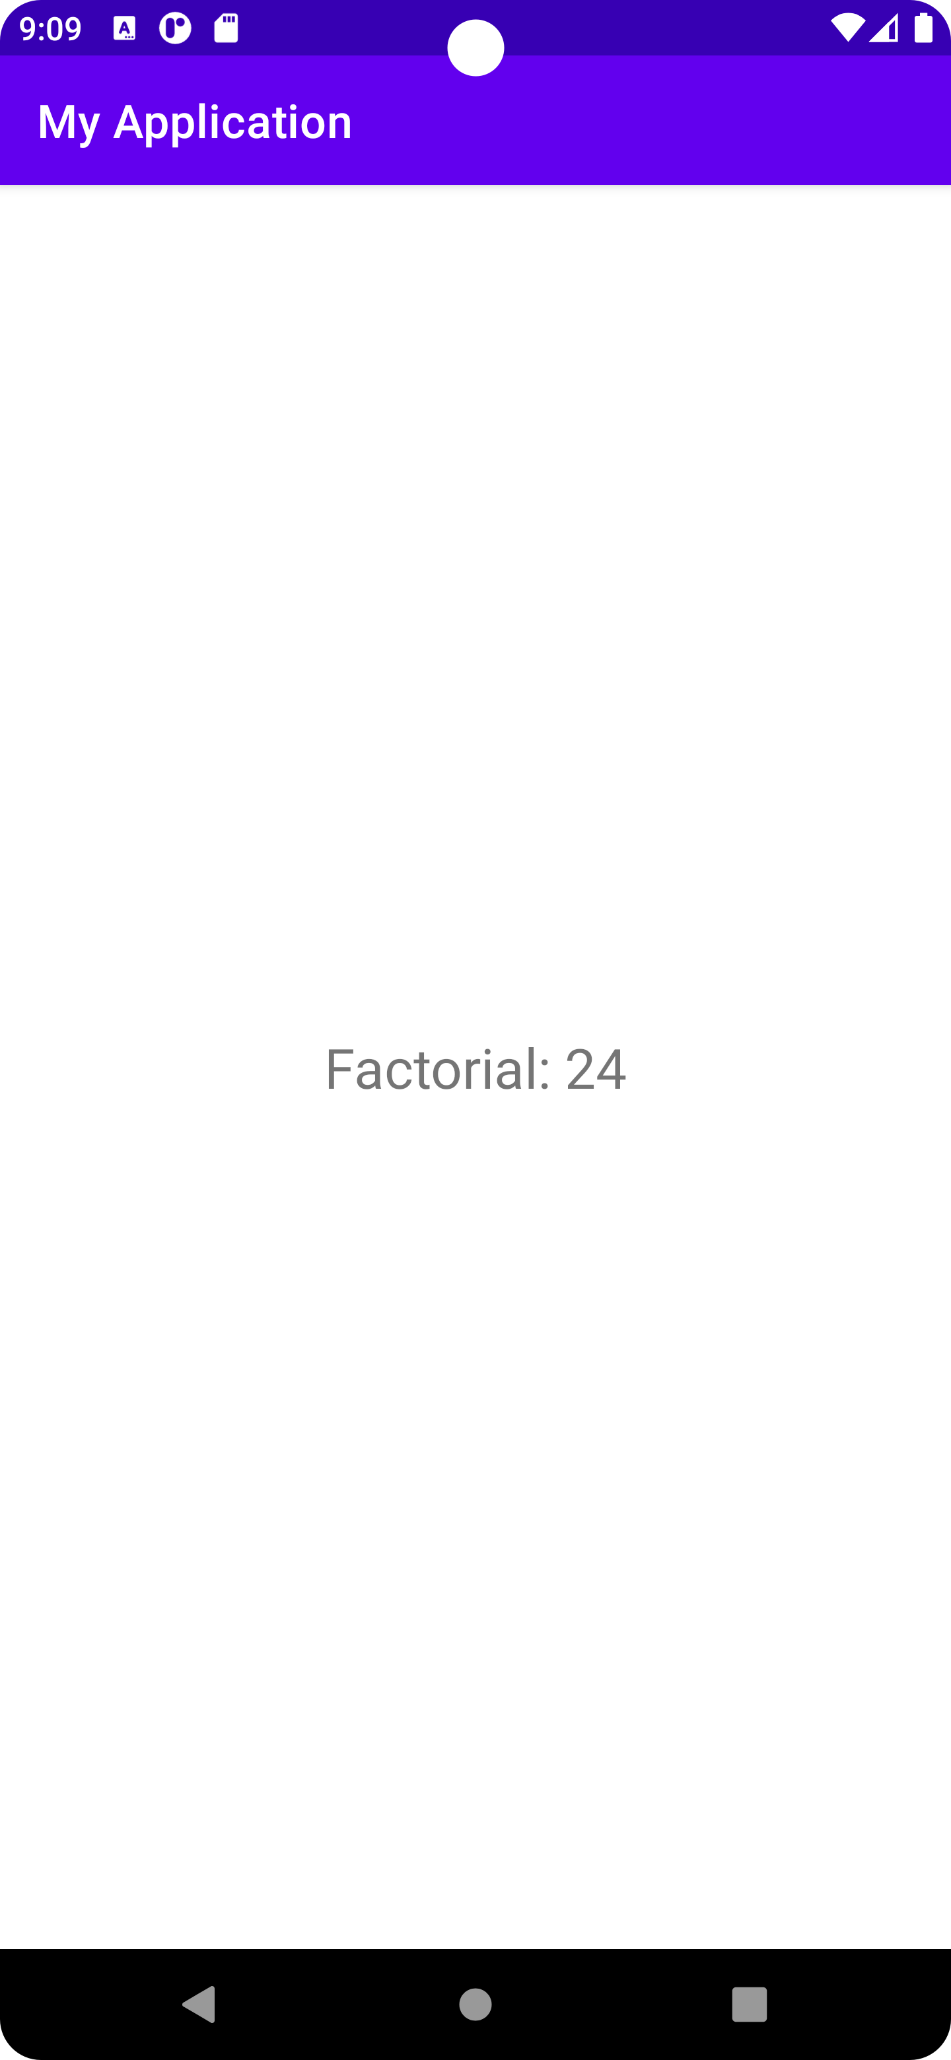

Q.1) Write a program to capture an image and display it using image view.
main_activity.xml
<?xml version="1.0" encoding="utf-8"?>
<RelativeLayout xmlns:android="http://schemas.android.com/apk/res/android"
android:layout_width="match_parent"
android:layout_height="match_parent"
android:paddingLeft="10dp"
android:paddingRight="10dp">
<Button
android:id="@+id/btnTakePicture"
android:layout_width="wrap_content"
android:layout_height="wrap_content"
android:text="Take a Photo"
android:textStyle="bold"
android:layout_centerHorizontal="true"
android:layout_alignParentBottom="true" />
<ImageView
android:layout_width="fill_parent"
android:layout_height="fill_parent"
android:id="@+id/capturedImage"
android:layout_above="@+id/btnTakePicture"/>
</RelativeLayout>

MainActivity.java

package com.example.practicalno231;
import android.content.Intent;
import android.graphics.Bitmap;
import android.os.Bundle;
import android.provider.MediaStore;
import android.view.View;
import android.widget.Button;
import android.widget.ImageView;
import android.widget.Toast;
import androidx.appcompat.app.AppCompatActivity;
public class MainActivity extends AppCompatActivity {
private Button btnCapture;
private ImageView imgCapture;
private static final int Image_Capture_Code = 1;
@Override
protected void onCreate(Bundle savedInstanceState) {
super.onCreate(savedInstanceState);
setContentView(R.layout.activity_main);
btnCapture =(Button)findViewById(R.id.btnTakePicture);
imgCapture = (ImageView) findViewById(R.id.capturedImage);
btnCapture.setOnClickListener(new View.OnClickListener() {
@Override
public void onClick(View v) {
Intent cInt = new Intent(MediaStore.ACTION_IMAGE_CAPTURE);
startActivityForResult(cInt,Image_Capture_Code);
}
});
}
@Override
protected void onActivityResult(int requestCode, int resultCode, Intent data) {
if (requestCode == Image_Capture_Code) {
if (resultCode == RESULT_OK) {
Bitmap bp = (Bitmap) data.getExtras().get("data");
imgCapture.setImageBitmap(bp);
} else if (resultCode == RESULT_CANCELED) {
Toast.makeText(this, "Cancelled", Toast.LENGTH_LONG).show();
}
}
}
}

Output-
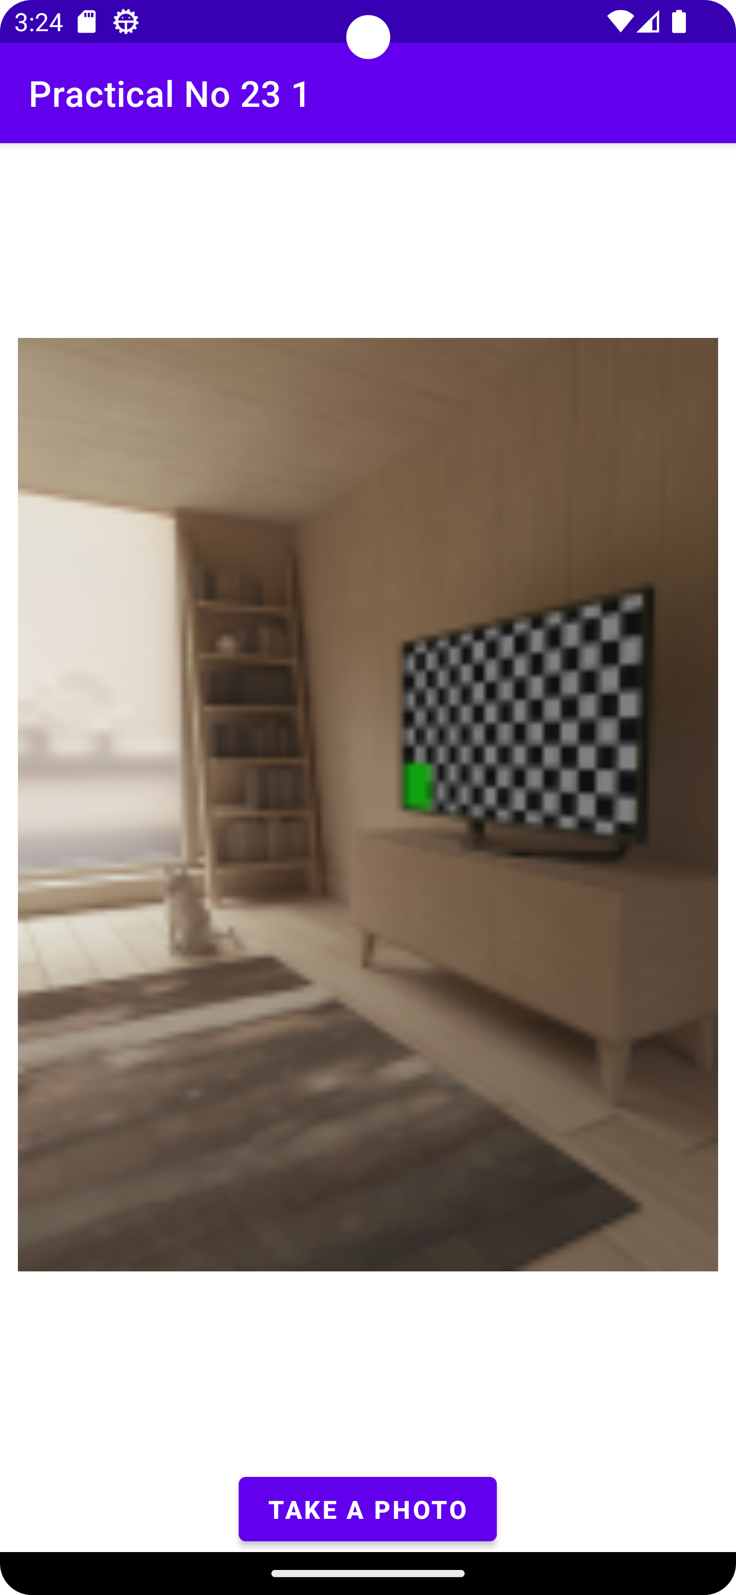
Q.1) Write a program to create the login form and display login successful/ Unsuccessful toast message.
Code-
main_activity.xml

<?xml version="1.0" encoding="utf-8"?>
<RelativeLayout xmlns:android="http://schemas.android.com/apk/res/android"
xmlns:app="http://schemas.android.com/apk/res-auto"
xmlns:tools="http://schemas.android.com/tools"
android:layout_width="match_parent"
android:layout_height="match_parent"
tools:context=".MainActivity">
<LinearLayout
android:layout_width="match_parent"
android:layout_height="wrap_content"
android:orientation="vertical"
android:layout_marginLeft="16dp"
android:layout_marginRight="16dp"
android:layout_centerInParent="true">
<EditText
android:layout_width="match_parent"
android:layout_height="wrap_content"
android:hint="UserName"
android:id="@+id/username"/>
<EditText
android:layout_width="match_parent"
android:layout_height="wrap_content"
android:hint="password"
android:id="@+id/password"
android:inputType="textPassword"
/>
<Button
android:layout_width="match_parent"
android:layout_height="wrap_content"
android:text="Login"
android:background="#3f76ff"
android:textColor="#fff"
android:id="@+id/login"/>
</LinearLayout>
</RelativeLayout>

MainActivity.java

package com.example.practicalno27;
import android.os.Bundle;
import android.view.View;
import android.widget.Button;
import android.widget.EditText;
import android.widget.Toast;
import androidx.appcompat.app.AppCompatActivity;
import java.util.Objects;
public class MainActivity extends AppCompatActivity {
EditText username,password;
Button login;
@Override
protected void onCreate(Bundle savedInstanceState) {
super.onCreate(savedInstanceState);
setContentView(R.layout.activity_main);
username=findViewById(R.id.username);
password=findViewById(R.id.password);
login=findViewById(R.id.login);
login.setOnClickListener(new View.OnClickListener() {
@Override
public void onClick(View view) {
if(Objects.equals(username.getText().toString(), "admin")&&Objects.equals(password.getText().toString(),"admin"))
{
Toast.makeText(MainActivity.this,"You have Authenticated Successfully",Toast.LENGTH_LONG).show();
}else
{
Toast.makeText(MainActivity.this,"Authentication Failed",Toast.LENGTH_LONG).show();
}
}
});
}
}

Output-
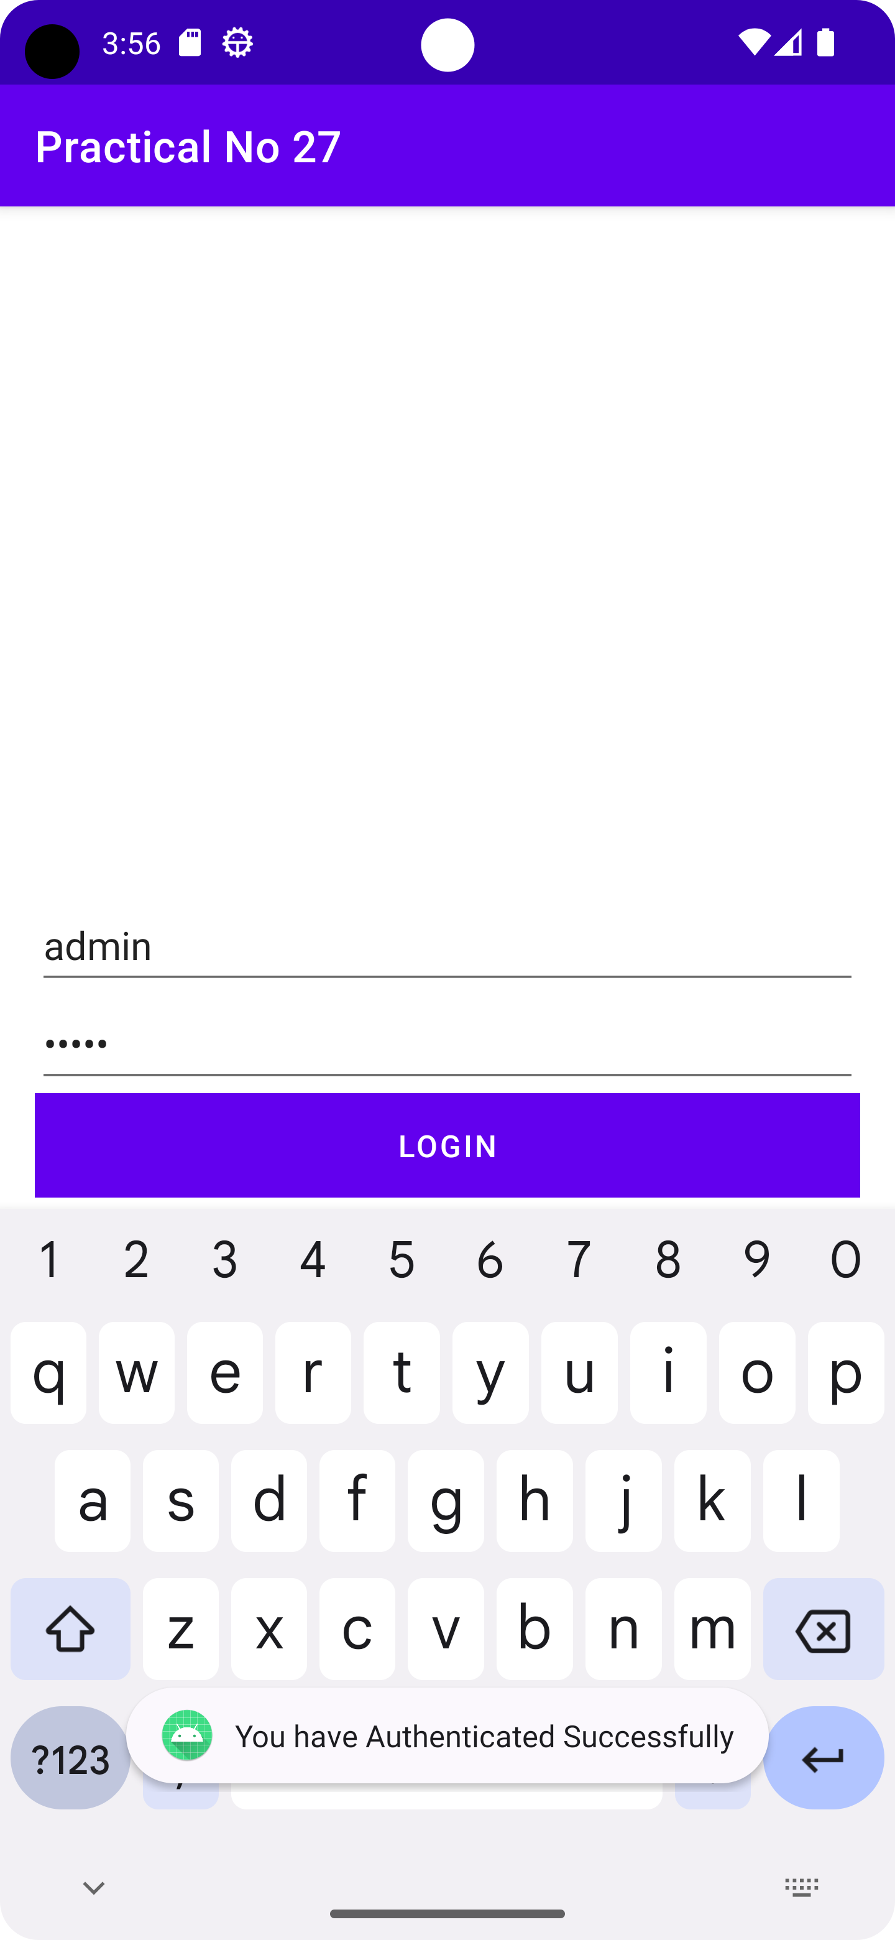

Q2) Develop an android application to create a Simple Calculator.
Code-
main_activity.xml
<?xml version="1.0" encoding="utf-8"?>
<TableLayout xmlns:android="http://schemas.android.com/apk/res/android"
xmlns:tools="http://schemas.android.com/tools"
android:layout_width="match_parent"
android:layout_height="match_parent"
android:orientation="vertical"
tools:context=".MainActivity">
<TableRow
android:layout_width="match_parent"
android:layout_height="wrap_content">
<EditText
android:id="@+id/etNumber1"
android:layout_width="226dp"
android:layout_height="wrap_content"
android:hint="Enter number 1" />
</TableRow>
<TableRow
android:layout_width="match_parent"
android:layout_height="wrap_content">
<EditText
android:id="@+id/etNumber2"
android:layout_width="match_parent"
android:layout_height="wrap_content"
android:hint="Enter number 2"
android:minHeight="48dp" />
</TableRow>
<TableRow
android:layout_width="match_parent"
android:layout_height="wrap_content">
<Button
android:id="@+id/btnAdd"
android:layout_width="201dp"
android:layout_height="match_parent"
android:text="Add Numbers" />
<Button
android:id="@+id/btnSub"
android:layout_width="match_parent"
android:layout_height="wrap_content"
android:text="Subtract Numbers" />
</TableRow>
<TableRow
android:layout_width="match_parent"
android:layout_height="wrap_content">
<Button
android:id="@+id/btnDiv"
android:layout_width="match_parent"
android:layout_height="match_parent"
android:text="Div Numbers" />
<Button
android:id="@+id/btnMul"
android:layout_width="match_parent"
android:layout_height="wrap_content"
android:text="Mul Numbers" />
</TableRow>
<TableRow
android:layout_width="match_parent"
android:layout_height="wrap_content">
<TextView
android:id="@+id/tvResult"
android:layout_width="match_parent"
android:layout_height="69dp"
android:text="Result will be displayed here" />
</TableRow>
</TableLayout>

MainActivity.java
package com.example.calculator;
import android.os.Bundle;
import android.view.View;
import android.widget.Button;
import android.widget.EditText;
import android.widget.TextView;
import androidx.appcompat.app.AppCompatActivity;
public class MainActivity extends AppCompatActivity {
private EditText etNumber1, etNumber2;
private Button btnAdd;
private Button btnSub;
private Button btnDiv;
private Button btnMul;
private TextView tvResult;
@Override
protected void onCreate(Bundle savedInstanceState) {
super.onCreate(savedInstanceState);
setContentView(R.layout.activity_main);

etNumber1 = findViewById(R.id.etNumber1);
etNumber2 = findViewById(R.id.etNumber2);
btnAdd = findViewById(R.id.btnAdd);
btnSub = findViewById(R.id.btnSub);
btnDiv = findViewById(R.id.btnDiv);
btnMul = findViewById(R.id.btnMul);
tvResult = findViewById(R.id.tvResult);

btnAdd.setOnClickListener(new View.OnClickListener() {
@Override
public void onClick(View v) {
int number1 = Integer.parseInt(etNumber1.getText().toString());
int number2 = Integer.parseInt(etNumber2.getText().toString());
int sum = number1 + number2;
tvResult.setText("Result: " + sum);
}
});
btnSub.setOnClickListener(new View.OnClickListener() {
@Override
public void onClick(View v) {
int number1 = Integer.parseInt(etNumber1.getText().toString());
int number2 = Integer.parseInt(etNumber2.getText().toString());
int diff = number1 - number2;
tvResult.setText("Result: " + diff);
}
});
btnDiv.setOnClickListener(new View.OnClickListener() {
@Override
public void onClick(View v) {
int number1 = Integer.parseInt(etNumber1.getText().toString());
int number2 = Integer.parseInt(etNumber2.getText().toString());
int Div = number1 / number2;
tvResult.setText("Result: " + Div);
}
});
btnMul.setOnClickListener(new View.OnClickListener() {
@Override
public void onClick(View v) {
int number1 = Integer.parseInt(etNumber1.getText().toString());
int number2 = Integer.parseInt(etNumber2.getText().toString());
int mul = number1 * number2;
tvResult.setText("Result: " + mul);
}
});
}
}
OUTPUT:-
